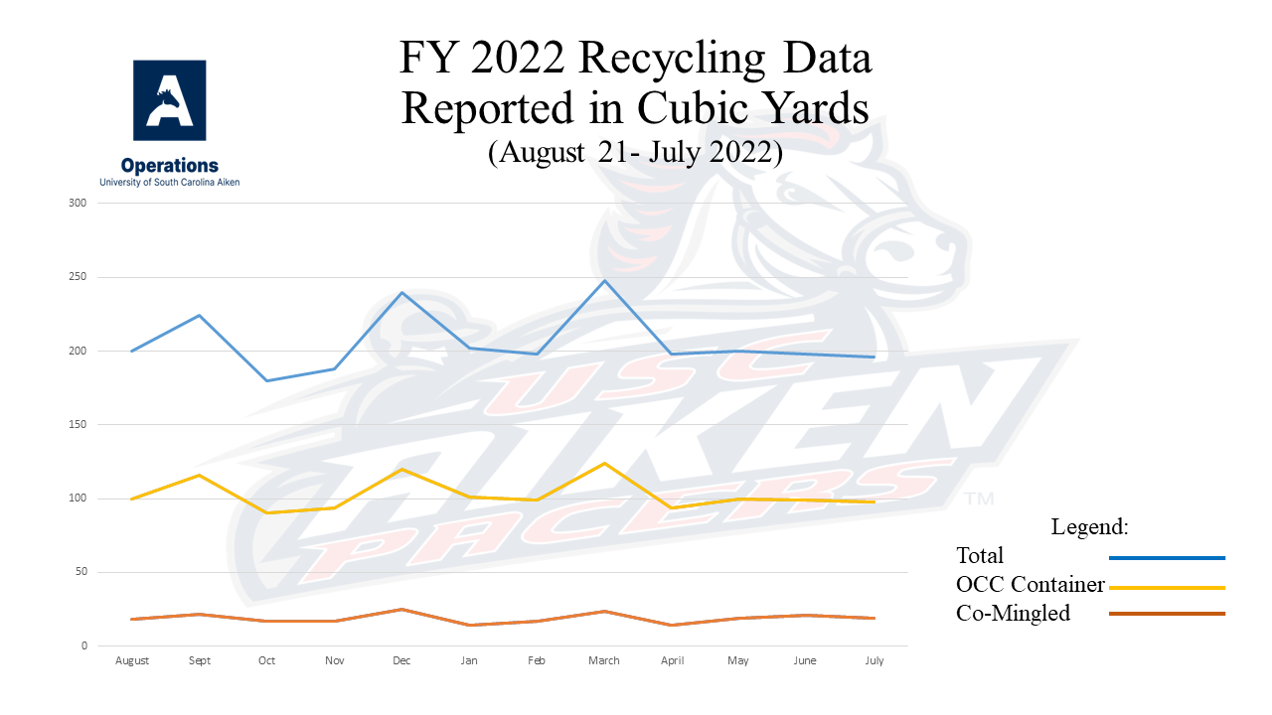

What's Recycled at USC Aiken?
USC Aiken is now recycling the following items:
- Mixed paper
- Cardboard
- Aluminum cans
- Plastic bottles
- Styrofoam peanuts
Mixed Paper
Mixed Paper includes all of the following:
White Paper, Colored Paper, Newspaper, Magazines, Catalogs, Junk Mail, Telephone Books, Pasteboard, Greeting Cards, Postcards, Post-it Notes, Brochures, Pamphlets, Hardcover Books (bagged separately), and posters (no glitter, paint, or crayon).
**Staples in the paper are acceptable, but do not leave paper clips or jumbo clips on the paper.
**Spiral notebooks can be discarded as well as long as the metal spiral has been removed.
Mixed paper does NOT include :
Any type of cover or insert that is vinyl coated or wax coated!
Cardboard
When recycling cardboard, the following steps should be taken:
- All materials in the box (i.e., paper, Styrofoam peanuts, plastic wrap, etc.) should be emptied out of the box first.
- All cardboard should be broken down by opening the bottom flaps before discarding it.
- You can dispose cardboard at any time in the green 30yd container between the baseball field and the tennis courts, but if you should need help or have any questions regarding this, you can contact the Environmental Health and Safety Manager.
Plastics
For all plastics recycling on campus, the caps to plastic bottles must be removed and placed in the regular trash before the plastic bottle can be disposed of in the gray container with gray lids designated for plastics recycling. Remember, we take type 1 and 2 plastics only!
Aluminum Cans
All aluminum cans should be thrown into the designated red containers with gray lids. Please try to empty the cans before disposing of them.
Styrofoam Peanuts
All Styrofoam packing peanuts can be recycled by collecting them and taking them to the Bookstore. If you have any questions regarding this, please contact the Bookstore at extension 3457.

Types of Recycling Containers on Campus
Blue Containers
Blue recycling containers are placed in various departmental offices around campus, and these containers are used for recycling mixed paper only.
Bag-it Systems
Bag-it Systems are located in various computer labs on campus, and these containers are used for recycling mixed paper.
Red Containers
Red recycling containers are placed in various locations around campus mainly in hallways of buildings, and these containers are used for recycling aluminum cans only.
Gray Containers
Gray recycling containers are placed in various locations around campus mainly in hallways of buildings, and these containers are used for recycling plastic bottles only. All caps must be removed from the plastic bottles before they can be recycled.
Indoor Recycling System
Indoor recycling centers have been placed in the H&SS Building to evaluate their effectiveness on campus. These centers will have collection areas for trash, mixed paper, aluminum cans, and plastic bottles. If these recycling centers have the desired effect, then additional centers will be placed around campus as funds are available.
Outdoor Recycling System
Outdoor recycling centers have been placed in the Quad area. These centers have collection areas for trash, aluminum cans, and plastic bottles.
30 Yard Mixed Paper Container
All mixed paper that is collected on campus is placed in this 30 yard container located in the loading dock area of the library.
30 Yard Cardboard Container
All cardboard is collected in this 30 yard container located between the baseball field and the tennis courts. However, cardboard can be recycled by placing it with the trash for housekeeping.

Locations of Recycling Containers
Blue Office Containers | Administration Bldg  Admissions (Rm 101H)  Advisement & Career Services (Rm 107)  Economic Development (Rm 110)  Institutional Effectiveness (Rm 108)  Office of the Registrar (Rm 109)  Mathematics (Rm 227)  Psychology (Rm 226)  Computer Services (Rm 236)  B&E Building  Conference Center & Continuing Education (Rm 100)  Counseling Center (Rm 126)  Assistive Technology Center (Rm 134)  Education (Rm 210)  Business (Rm 222)  2nd Floor Copier  Wellness Center (Rm 20C)  Children's Center  Office  Etherredge Center  Ticket Office  Gregg-Graniteville Library  Copiers  H&SS Bldg  Office Suite 101  Suite 204
Bag-it Systems | Administration Bldg  Psychology Computer Lab (Rm 214)  Math Lab (Rm 221)  B&E Bldg  Computer Lab (Rm 238)  H&SS Bldg  Writing Room (Rm 112)  Pacer Times (Rm 110)  Language Lab (Rm 107)  Computer Classroom (Rm 106)  Nursing Bldg  Computer Lab (Rm 136)  Student Activities Center  Student Life Office  Science Bldg  Computer Lab (Rm 101)  Indoor Recycling System  H&SS Bldg (Only)  Across from Rm 106, Rm 109, Rm 116, Rm 203, and Rm 210  Nursing Bldg  Office (Rm 101)  Pacer Downs  Office  Alumni House  Chancellor's Office  External Affairs  Development & Alumni Affairs  Ruth Patrick Science Education Center  Workroom (Rm 109)  Workroom (Rm 213)  Workroom (Rm 312)  Science Bldg  Biology/Geology (Rm 201)  Academic Affairs/Chemistry & Physics (Rm 214)  Student Activities Center  Athletics Office  Student Life Office  Bookstore  Food Services  Supply & Maintenance Bldg  Office
Red Containers & Gray Containers  (Both are grouped together in all locations.) | Administration Bldg  Courtyard by Auditorium (Rm 106)  2nd Floor Hallway by Rm 215  2nd Floor Hallway by Rm 234  Etherredge Center  Vending Area near Rm 140  B&E Bldg  1st Floor hallway by Rm 131  1st Floor hallway by Rm 136  2nd Floor hallway by Elevator  2nd Floor hallway by Rm 236  Student Activities Center  Quad side entrance  Parking Lot A entrance  Ruth Patrick Science Education Center  1st Floor hallway by lunchroom  2nd Floor hallway by Rm 214  3rd Floor hallway by Rm 313  Nursing Bldg  Rm 122  Hallway by Rm 114  Science Bldg  1st Floor hallway by Rm 105  2nd Floor hallway by Rm 214

The following are important questions and answers you might have regarding recycling on campus:
What is considered mixed paper that I can recycle in my box?
White paper, Colored paper, Newspaper, Junk mail, Telephone books, Pasteboard (i.e., cereal boxes), Hardcover books, Catalogs, and Magazines are all considered recyclable paper. Hardcover books must separated and bagged before disposal. The only exceptions are any type of cover or insert that is vinyl coated or wax coated. If you can not tear it, it is not paper!!!
Staples in the paper are ok, but do not leave paper clips, jumbo clips, or the like on the paper. Spiral notebooks can be discarded as well as long as the metal spiral has been removed. Posters with ink and magic marker are fine to recycle, but poster with paint, glitter, Styrofoam, and crayon are NOT recyclable.
Should I bag my paper before I dispose of it?
No, the paper to be recycled should be placed in all containers loose. No paper should be bound by rubber bands, string, or plastic bags. Only hardcover textbooks should be placed in bags before recycling.
When housekeeping collects the paper from our blue recycling containers, what happens to the paper?
Housekeeping will pick up the paper from the blue recycling bins and place the paper at a central location within their building assignments. Two housekeepers have partial responsibility to recycling efforts on campus, and they pick up the recycled materials from the various locations on campus three times a week (Monday, Wednesday, and Friday) placing it in the appropriate container for dumping.
My office generates a significant amount of cardboard, but how should we dispose of it?
The university does recycle cardboard as well, and the container to collect the cardboard is located between the tennis courts and the baseball field. The following steps should be taken when recycling cardboard:
- All materials in the box (i.e., paper, styrofoam peanuts, plastic wrap, etc.) should be emptied out of the box first
- All cardboard should be broken down by opening the bottom flaps before discarding it.
- You can dispose cardboard at any time, but if you should need help or have any questions regarding this, you can contact me at LenE@usca.edu.
How many types of plastics are there, and what types do we recycle on campus?
There are actually seven different types of plastics that can be recycled. See the chart below for the different types of plastics and examples of each. However, we only accept type 1 and 2 plastics in our recycling program!
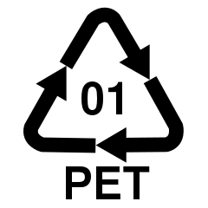 | PETE Polyethylene Terephthalate- Soft drink, beer, and Two-liter beverage bottles, mouthwash bottles, boil-in-bag pouches.
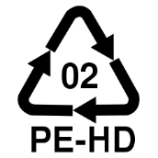 | HDPE High Density Polyethylene- Milk jugs, water and juice containers, trash bags, detergent bottles, yogurt and margarine tubs.
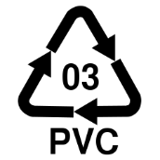 | V Vinyl (sometimes seen as PVC, for polyvinyl chloride)- Cooking oil bottles, packaging around meat
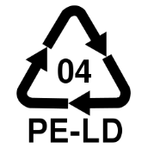 | LDPE Low Density Polyethylene- Grocery bags, produce bags, food wrap, bread bags.
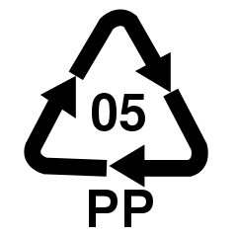 | PP Polypropylene- Yogurt containers, shampoo bottles, straws, margarine tubs, diapers.
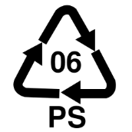 | PS Polystyrene- Hot beverage cups, take-home boxes, egg cartons, meat trays
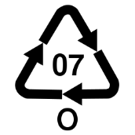 | OTHER- All other types of plastics or packaging made from more than one type of plastic.
Where are the recycle containers for the paper, aluminum cans, and plastic bottles located on campus?
The blue recycling containers are located in most departmental offices by a copier or a printer or in an office workroom. All paper is eventually disposed of in a large container by the library.
Aluminum cans should be disposed in the red containers found in various locations around campus. These are for cans only, so please pay careful attention when discarding of your trash. All aluminum cans are ultimately disposed of in plastic bags in the large container by the library as well.
Plastic Bottles can be disposed of in the gray containers on campus, the indoor recycling centers located in the H&SS Building, and the outdoor recycling centers in the Quad area. However, the caps should be removed from all plastic bottles before they are disposed. The caps to the plastic bottles should be thrown into the regular waste.

